**INTRODUCTION TO   
DATABASE**

**2021/2022**

**PROJECT  
STICKEREST**

**Francesco Mazzini  
19080**

**STICKEREST**

**Requirements:**

It is asked to realize a platform, called STICKEREST, for selling and downloading stickers in different ways.

The users can be of two kinds, or even both at the same time: designers, those who create the digital artwork of the sticker and publish it; clients, those who use the platform to buy, download these artworks. The artworks published are called stickers and they are offered in packs. These sticker Packs are offered as 3 different products: pack of WhatsApp digital stickers*, downloadable and that can either be free or have a cost chosen by the creator; pack of real physique stickers, for which people can ask for shipping; pack of NFTs**, for which people can buy each NFT of the pack separately (but not on our platform). The creator of a sticker pack (who can be only one per each) can choose in which form this pack is going to be offered, but at least it will have to be a WhatsApp digital sticker pack, and optionally NFTs and/or physical pack. For each physical order, a shipping company may be assigned (depending on which one covers that territory part) in case the user chooses to receive the order at home. Alternatively, they can also choose to pick up the order in one of the local printing shops near to them, which are affiliated with STICKEREST. This is possible both to let the user receive the order at a pick-up point and to enhance the local shops and the small businesses. If the user decides to have it at home, also a printing company among those affiliated is chosen and that place is where the delivery would start.

There are such much information that we want to keep track of. Of WhatsApp sticker packs, we want to track the number of downloads and if it has a price, how much it costs (if it is free this is just set to 0.00), of NFT packs, we want to store the link that redirects the user to the Opensea marketplace where this NFT collection is currently being sold (because STICKEREST automatically for each artwork, that needs to be sold as NFT, uploads the image as NFT on an already known marketplace and then when sold, STICKEREST gives parts of the money back to the creator), of the physical sticker pack, we want the number of sold packs and the price set by the creator, but in a standard range set by the platform (STICKEREST will give part of the money earned with the pack back to the creator). More generally a sticker pack also has an ID that identifies it, a name and all the images of the stickers (that can be at least 1 and max 100) (of which we want to know the image file associated and the order, keeping in mind that in the same pack no stickers with the same image file exists) that compose that pack, when it has been uploaded and from whom. For each user we want to know their nickname (which cannot be equal among users), email and password (encrypted), if they are a client, also the address where they live (composed of city, cap, street, nation, province and each is unique only thanks to the street within the cap, province and nation ) is needed, whereas if they are sticker designers also an email for PayPal payments is needed and one address for invoices. In the case of designers, we also want to know their VAT number if they own one, and additionally, a number (1 to 6) called “level” which is going to be used as an indicator of their performance on the website, so to give advantages to good creators. Users can therefore buy these packs making orders. Orders can contain multiple packs but these can only be of the same kind within the same order and for each, we want the identification number, the products to be sent and the date when this order was made. Moreover, it is wanted the place where it is going to be printed and the shipping company used, only if it contains physique packs. If it contains digital WhatsApp packs we manage it just like a normal download (priceless or not) with the fact that we kept track of who did it and when, in the case of NFTs we do not want to keep track of this, since the purchases are managed by another marketplace. For each shipping company we want to keep track of their identification acronym, which is inserted at their registration on the platform, the acronym of the countries where they operate, the fees asked for each shipping, their name.

For each printing “entity” we want to know their code (VAT number) for manufacturing invoices, their address, name, whether they are either a printing company or a local printing shop. For the firsts, we also want to know their pec email while for the seconds only a reachable phone number (since more direct contact is needed).

It is also important to take into consideration that when an order is analyzed often it is also important to see who made it. When the user searches for WhatsApp sticker packs, it needs to show also in which form it is offered (as NFT and/or physical), who made it and when it has been created. Lastly, it is important that accessing a printing entity allows also to know immediately also where it is located so that decisions can be taken by that.

Speaking on volumes of the platform, marketing estimations say that is likely to have for the first long period an amount of circa 10k users, 100 shipping companies and 800 among printing companies and local printing shops registered to the platform. It is estimated that, among users, for each designer, there will be 4,5 clients and ca. 1/10 of all users will be both. Moreover, on average, each designer creates 3 WhatsApp sticker packs and each of them is on average composed of 15 images. Additionally, among these WhatsApp sticker packs, more than 2/3 is also a physical sticker pack, as well as more than 2/3 is also a NFT pack. Estimations also say that for each client more than 1,5 orders are associated, among them the most is digital (ca 70 %) and the minority physical (ca 30%). Regarding the printing entity, there will be registered for each printing company ca. 3 local printing shops, so to cover the most possible part of territories. Another estimation says that in each order of WhatsApp sticker packs there are 1,8 Whatsapp sticker packs (on average many buy only one, but some of them more than 1), about physical orders instead it is 1,5 of physical sticker packs and more than 60% of them are asked to be shipped. About shippings, clients usually use their registered address to receive the orders, it is estimated that less than half of them use another address.

Speaking on actions it is also estimated that there will be 500 digital orders per day and users will look for information (included images) of WhatsApp sticker packs 1k a day. Physical orders should be much less, like 10 a day, and physical sticker packs will be of interest for 500 times a day by the users. Clients are also interested in seeing their past orders (500 a day) and in looking for the most downloaded packs, displayed in the homepage (10k times a day). It is also estimated that ca. 20 sticker packs are created every day.

*WhatsApp digital sticker = they are a type of file used by people on social networks like WhatsApp. These packs are downloadable as a unique file and importable automatically thanks to the software on the smartphone.

**NFTs = they are Non-Fungible Tokens, unique codes on a blockchain represented by a file (in this case the image also used for the sticker), traded between people. Each pack of stickers become a collection of NFTs and it is sold by the platform on an external market (like Opensea) on behalf of the designer.

**STRUCTURED AND ORGANIZED REQUIREMENTS**

**General Statement:**

It is asked to realize a platform, called STICKEREST, for selling and downloading stickers in different ways.

**Statements Concerning Users:**

The users can be of two kinds, or even both at the same time: designers, those who create the digital artwork of the sticker and publish it; clients, those who use the platform to buy, download these artworks. For each user we want to know their nickname (which cannot be equal among users), email and password (encrypted), if they are a client, also the address where they live (composed of city, cap, street, nation, province and each is unique only thanks to the street within the cap, province and nation ) is needed, whereas if they are sticker designers also an email for PayPal payments is needed and one address for invoices. In the case of designers, we also want to know their VAT number if they own one, and additionally, a number (1 to 6) called “level” which is going to be used as an indicator of their performance on the website, so to give advantages to good creators. Users can therefore buy these packs making orders.

Speaking on volumes of the platform, marketing estimations say that is likely to have for the first long period an amount of circa 10k users, 100 shipping companies and 800 among printing companies and local printing shops registered to the platform. It is estimated that, among users, for each designer, there will be 4,5 clients and ca. 1/10 of all users will be both.

**Statements Concerning Sticker Packs:**

The artworks published are called stickers and they are offered in packs. These sticker Packs are offered as 3 different products: pack of WhatsApp digital stickers*, downloadable and that can either be free or have a cost chosen by the creator; pack of real physique stickers, for which people can ask for shipping; pack of NFTs**, for which people can buy each NFT of the pack separately (but not on our platform). The creator of a sticker pack (who can be only one per each) can choose in which form this pack is going to be offered, but at least it will have to be a WhatsApp digital sticker pack, and optionally NFTs and/or physical pack. Of WhatsApp sticker packs, we want to track the number of downloads and if it has a price, how much it costs (if it is free this is just set to 0.00), of NFT packs, we want to store the link that redirects the user to the Opensea marketplace where this NFT collection is currently being sold (because STICKEREST automatically for each artwork, that needs to be sold as NFT, uploads the image as NFT on an already known marketplace and then when sold, STICKEREST gives parts of the money back to the creator), of the physical sticker pack, we want the number of sold packs and the price set by the creator, but in a standard range set by the platform (STICKEREST will give part of the money earned with the pack back to the creator). More generally a sticker pack also has an ID that identifies it, a name and all the images of the stickers (that can be at least 1 and max 100) (of which we want to know the image file associated and the order, keeping in mind that in the same pack no stickers with the same image file exists) that compose that pack, when it has been uploaded and from whom.

When the user searches for WhatsApp sticker packs, it needs to show also in which form it is offered (as NFT and/or physical), who made it and when it has been created. Moreover, on average, each designer creates 3 WhatsApp sticker packs and each of them is on average composed of 15 images. Additionally, among these WhatsApp Sticker Packs, more than 2/3 is also a physical sticker pack, as well as more than 2/3 is also a NFT pack. Another estimation says that in each order of WhatsApp sticker packs there are 1,8 Whatsapp sticker packs (on average many buy only one, but some of them more than 1), about physical orders instead it is 1,5 of physical sticker packs and circa more than 60% of them are asked to be shipped. Speaking on actions it is also estimated that there will be 500 digital orders per day and users will look for information (included images) of WhatsApp sticker packs 1k a day. Physical orders should be much less, like 10 a day, and physical sticker packs will be of interest for 500 times a day by the users. Clients are also interested in seeing their past orders (500 a day) and in looking for the most downloaded packs, displayed in the homepage (10k times a day). It is also estimated that ca. 20 sticker packs are created every day.

**Statements Concerning Orders:**

For each physical order, a shipping company may be assigned (depending on which one covers that territory part) in case the user chooses to receive the order at home. Alternatively, they can also choose to pick up the order in one of the local printing shops near to them, which are affiliated with STICKEREST. This is possible both to let the user receive the order at a pick-up point and to enhance the local shops and the small businesses. If the user decides to have it at home, also a printing company among those affiliated is chosen and that place is where the delivery would start. Orders can contain multiple packs but these can only be of the same kind within the same order and for each, we want the identification number, the products to be sent and the date when this order was made. Moreover, it is wanted the place where it is going to be printed and the shipping company used, only if it contains physique packs. If it contains digital WhatsApp packs we manage it just like a normal download (priceless or not) with the fact that we kept track of who did it and when, in the case of NFTs we do not want to keep track of this, since the purchases are managed by another marketplace.

It is also important to take into consideration that when an order is analyzed often it is also important to see who made it. Estimations also say that for each client more than 1,5 orders are associated, among them the most is digital (ca 70 %) and the minority physical (ca 30%). Another estimation says that in each Order of WhatsApp Sticker Packs there are 1,8 Whatsapp Sticker Packs (on average many buy only one, but some of them more than 1), about Physical Orders instead it is 1,5 of Physical Sticker Packs and circa more than 60% of them are asked to be shipped. Speaking on actions it is also estimated that there will be 500 Digital Orders per day and users will look for information (included images) of WhatsApp Sticker Packs 1k a day. Physical Orders should be much less, like 10 a day, and physical sticker packs will be of interest for 500 times a day by the users. Clients are also interested in seeing their past orders (500 a day) and in looking for the most downloaded packs, displayed in the homepage (10k times a day).

**Statements Concerning Printing Entities:**

For each physical order, a shipping company may be assigned (depending on which one covers that territory part) in case the user chooses to receive the order at home. Alternatively, they can also choose to pick up the order in one of the local printing shops near to them. For each printing “entity” we want to know their code (VAT number) for manufacturing invoices, their address, name, whether they are either a printing company or a local printing shop. For the firsts, we also want to know their pec email while for the seconds only a reachable phone number (since more direct contact is needed).

Lastly, it is important that accessing a printing entity allows also to know immediately also where it is located so that decisions can be taken by that. Speaking on volumes of the platform, marketing estimations say that is likely to have for the first long period an amount of circa 10k users, 100 shipping companies and 800 among printing companies and local printing shops registered to the platform. Regarding the printing entity, there will be registered for each printing company ca. 3 local printing shops, so to cover the most possible part of territories.

**Statements Concerning Shipping Companies:**

For each shipping company we want to keep track of their identification acronym, which is inserted at their registration on the platform, the acronym of the countries where they operate, the fees asked for each shipping, their name.

Speaking on volumes of the platform, marketing estimations say that is likely to have for the first long period an amount of circa 10k users, 100 shipping companies and 800 among printing companies and local printing shops registered to the platform.

**CONSTRUCTION OF THE GLOSSARY**

|  |  |  |  |
| --- | --- | --- | --- |
| **Term** | **Description** | **Synonyms** | **Connections** |
| **User** | A user of the platform. They can be Designer and/or Client | - | Sticker Pack, Order |
| **Sticker Pack** | It is the product that the platform sells. It is a WhatsApp sticker pack and can be also an NFT sticker pack and/or physical sticker pack. | - | User, Order |
| **Order** | It represents the transition of a sticker pack instance given to the user. It can be digital or physical, depending on in which form is the product sold/downloaded | - | User, Sticker Pack, Printing Entity, Shipping Company |
| **Printing Entity** | Company that prints sticker packs. They may be local shops or alternatively real printing companies | - | Order |
| **Shipping Company** | Company that ships orders of physical sticker packs. | - | Order |

**DIAGRAM OF THE CONCEPTUAL SCHEMA**

**E/R Conceptual Schema**

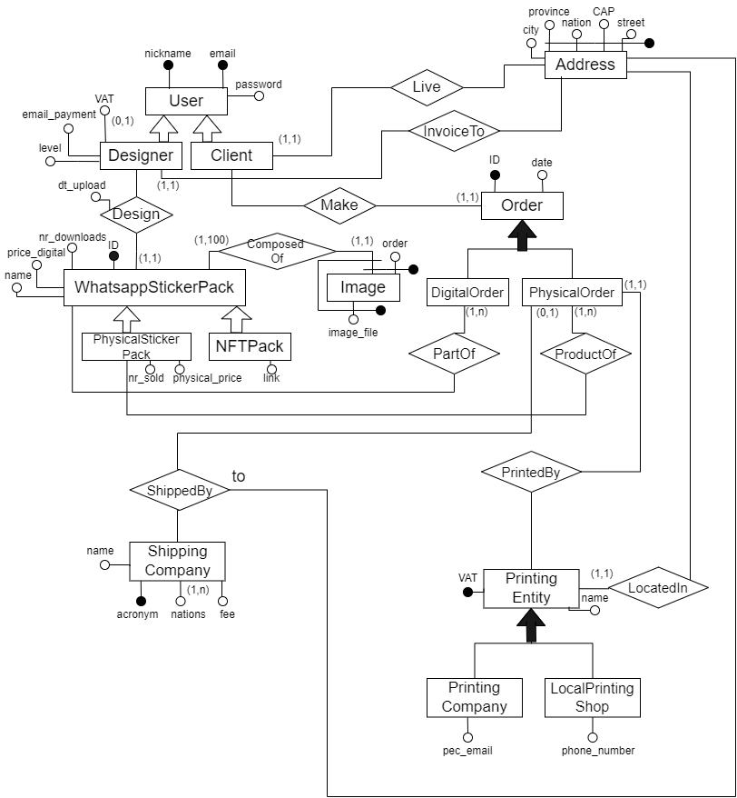

**DATA DICTIONARIES**

**Data Dictionary: Entities**

|  |  |  |  |
| --- | --- | --- | --- |
| **Entity** | **Description** | **Attributes** | **Identifiers** |
| User | User of the platform | nickname email password | { nickname } { email } |
| Designer | User as Designer, who designs artwork | nickname  email  password  VAT  email_payment  level | { nickname } { email } |
| Client | User as Client, who buys products | nickname  email  password | { nickname } { email } |
| Address | Address information | street CAP nation province city | { street, CAP, nation, province} |
| Order | Representation of a group of products ordered by a client | ID date | { ID } |
| DigitalOrder | Order of digital stickers | ID date | { ID } |
| PhysicalOrder | Order of physical stickers | ID date | { ID } |
| WhatsAppSticker Pack | Pack of WhatsApp stickers | ID name digital_price nr_downloads | { ID } |
| PhysicalStickerPack | Pack of WhatsApp stickers being sold also as physical | ID name digital_price nr_downloads  physical_price  nr_sold | { ID } |
| NFTPack | Pack of WhatsApp stickers being sold also as NFT | ID name digital_price nr downloads  link | { ID } |
| Image | Image of stickers | Image_file  order | { order, WhatsAppStickerPack }  { image file, WhatsAppStickerPack } |
| PrintingEntity | Entity that prints physically stickers | VAT  name | { VAT} |
| PrintingCompany | Printing entity that is a company | VAT  name  pec email | { VAT} |
| LocalPrintingShop | Printing entity that is a local shop | VAT  name  phone number | { VAT} |
| ShippingCompany | Company that ships orders | acronym name nations  fee | { acronym } |

**Data Dictionary: Relationships**

|  |  |  |  |  |
| --- | --- | --- | --- | --- |
| **Relationship** | **Description** | **Components** | **Attributes** | **Identifiers** |
| Live | Where the client currently live | Client, Address |  |  |
| InvoiceTo | Address for a designer for invoices | Designer,  Address |  |  |
| Design | Sticker packs made by a designer | Designer, WhatsappStickerPack | dt_upload |  |
| Make | Orders made by a client | Client, Order |  |  |
| PartOf | Stickers that compose a digital order | WhatsappStickerPack, DigitalOrder |  |  |
| ProductOf | Physical stickers that compose the physical order | PhysicalStickerPack, PhysicalOrder |  |  |
| ComposedOf | Images that compose the sticker pack | WhatsappStickerPack, Image |  |  |
| ShippedBy (to) | Where the shipping ends (address of the client) | PhysicalOrder, ShippingCompany, Address |  |  |
| PrintedBy | The company enrolled in printing the pack of stickers | PhysicalOrder, PrintingEntity |  |  |
| LocatedIn | Where the printing entity is located | PrintingEntity, Address |  |  |

**Data Dictionary: Attributes**

|  |  |  |  |
| --- | --- | --- | --- |
| **Attribute** | **Entity/Relationship** | **Domain** | **Description** |
| nickname | User | Varchar | Nickname of the user |
| email | User | Varchar | Email of the user |
| password | User | Varchar | Password of the user (encrypted) |
| VAT | Designer | Varchar | Number of characters is different for nations |
| email_payment | Designer | Varchar | Email of the designer used to be paid |
| level | Designer | Integer [1:6] | Level of the designer |
| dt_upload | Design | Date | Date of upload of a sticker pack |
| street | Address | Varchar | Street |
| CAP | Address | Varchar(10) | CAP (10 because it is different across the world) |
| nation | Address | Varchar | Nation |
| province | Address | Varchar(7) | Province (7 because it is different across the world) |
| city | Address | Varchar | City |
| ID | Order | Integer | Unique identifier of the order |
| date | Order | Date | Date when the order has been made |
| ID | WhatsappStickerPack | Integer | Unique identifier of the sticker pack |
| name | WhatsappStickerPack | Varchar | Name of the sticker pack |
| price_digital | WhatsappStickerPack | Decimal | Price of the digital sticker pack (0 if free) |
| nr_downloads | WhatsappStickerPack | Integer | Number of times it has been downloaded/bought |
| order | Image | Integer | Cardinal order of the images inside the pack |
| image_file | Image | Varchar | Names of the file of the images |
| nr_sold | PhysicalStickerPack | Integer | Number of times it has been sold |
| physical_price | PhysicalStickerPack | Decimal | Price of the physical sticker pack |
| link | NFTPack | Varchar | Link to the marketplace where this NFT is currently sold |
| acronym | ShippingCompany | Varchar | Acronym which identifies the shipping company |
| name | ShippingCompany | Varchar | Extended name of the shipping company |
| nations | ShippingCompany | Char(2) | Nations in which the company operate |
| fee | ShippingCompany | Decimal | Fee asked for shipping by the company |
| VAT | PrintingEntity | Varchar | VAT number of the printing entity |
| name | PrintingEntity | Varchar | Name of the printing entity |
| pec_email | PrintingCompany | Varchar | Pec Email of the printing company |
| phone_number | LocalPrintingShop | Varchar | Phone number of the local printing shop |

**Data Dictionary: External Constraints**

|  |  |
| --- | --- |
| **External Integrity Constraints** | |
| 1 | For each instance (PhysicalOrder: v, PrintingEntity: u) of PrintedBy, if u is an instance of PrintingCompany then v participates to ShippedBy, otherwise if u is an instance of Local PrintingShop then v does not participate to ShippedBy. |
| 2 | Attribute “level” has a range of [1, 6]. |
| 3 | Attribute “nr_downloads” of a certain v instance of WhatsappStickerPack is equal to the number of instances of PartOf in which v participates. |
| 4 | Attribute “nr_sold” of a certain v instance of PhysicalStickerPack is equal to the number of instances of ProductOf in which v participates. |
| 5 | For each v in User, it also has to be instance of Designer, Client or both. |

**COST EVALUATION**

**Table of Volumes**

|  |  |  |
| --- | --- | --- |
| **Concept** | **Construct** | **Volume** |
| User | Entity | 10 000 (2 000 + 9 000 – 1000 (both) ) |
| Designer | Entity | 2 000 |
| Client | Entity | 9 000 (4,5 x 2000) |
| Address | Entity | 9 000 (Clients) + 2 000 (Designer) + 800 (PrintingEntities) + 1000 (< 50% of ShippedBy, because most of Clients use their registered address) = 12 800 |
| WhatsappStickerPack | Entity | 6 000 (2 000 * 3) |
| Image | Entity | 90 000 (6 000 * 15) |
| PhysicalStickerPack | Entity | 4 000 (2/3 * 6000) |
| NFTPack | Entity | 4 000 (2/3 * 6000) |
| Order | Entity | 14 000 (> 9 000 * 1,5) |
| DigitalOrder | Entity | 10 000 (~ 70% of 14 000) |
| PhysicalOrder | Entity | 4 000 (~ 30% of 14 000) |
| ShippingCompany | Entity | 100 |
| PrintingEntity | Entity | 800 |
| PrintingCompany | Entity | 200 |
| LocalPrintingShop | Entity | 600 (200 * 3) |
| Design | Relationship | 6 000 |
| InvoiceTo | Relationship | 2 000 |
| Live | Relationship | 9 000 |
| Make | Relationship | 14 000 |
| ComposedOf | Relationship | 90 000 |
| PartOf | Relationship | 18 000 (10 000 * 1,8) |
| ProductOf | Relationship | 6 000 (4 000 * 1,5) |
| ShippedBy | Relationship | 2 500 (> 60% of 4 000) |
| PrintedBy | Relationship | 4 000 |
| LocatedIn | Relationship | 800 |

**Table of Operations**

|  |  |  |
| --- | --- | --- |
| **Operation** | **Type** | **Frequency** |
| 1. Client displays their past orders | Interactive | 500 / day |
| 2. Client/Designer searches most downloaded packs | Interactive | 10k / day |
| 3. Client/Designer wants to display all images of a WhatsappStickerPack | Interactive | 1k / day |
| 4. Client makes a new DigitalOrder | Interactive | 500 / day |
| 5. Client changes his/her address | Interactive | 10 / day |

**DIAGRAM OF THE RESTRUCTURED CONCEPTUAL SCHEMA**

**E/R Conceptual Schema Restructured**

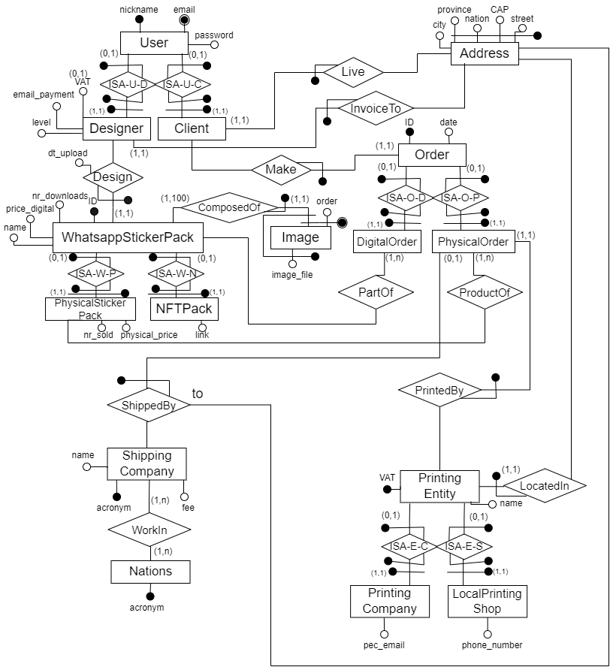

**DATA DICTIONARIES**

**Data Dictionary: Entities**

|  |  |  |  |
| --- | --- | --- | --- |
| **Entity** | **Description** | **Attributes** | **Identifiers** |
| User | User of the platform | nickname email password | { nickname } { email } |
| Designer | User as Designer, who designs artwork | nickname  email  password  VAT  email_payment  level | { nickname } { email } |
| Client | User as Client, who buys products | nickname  email  password | { nickname } { email } |
| Address | Address information | street CAP nation province city | { street, CAP, nation, province} |
| Order | Representation of a group of products ordered by a client | ID date | { ID } |
| DigitalOrder | Order of digital stickers | ID date | { ID } |
| PhysicalOrder | Order of physical stickers | ID date | { ID } |
| WhatsAppSticker Pack | Pack of WhatsApp stickers | ID name digital_price nr_downloads | { ID } |
| PhysicalStickerPack | Pack of WhatsApp stickers being sold also as physical | ID name digital_price nr_downloads  physical_price  nr_sold | { ID } |
| NFTPack | Pack of WhatsApp stickers being sold also as NFT | ID name digital_price nr downloads  link | { ID } |
| Image | Image of stickers | image_file  order | { order, WhatsAppStickerPack }  { image file, WhatsAppStickerPack } |
| PrintingEntity | Entity that prints physically stickers | VAT  name | { VAT } |
| PrintingCompany | Printing entity that is a company | VAT  name  pec email | { VAT } |
| LocalPrintingShop | Printing entity that is a local shop | VAT  name  phone number | { VAT } |
| ShippingCompany | Company that ships orders | acronym name  fee | { acronym } |
| Nations | Nations in which shipping companies operate | acronym | { acronym } |

**Data Dictionary: Relationships**

|  |  |  |  |  |
| --- | --- | --- | --- | --- |
| **Relationship** | **Description** | **Components** | **Attributes** | **Identifiers** |
| ISA-U-D | Keeps track of users who are designers | User, Designer |  | { User } { Designer } |
| ISA-U-C | Keeps track of users who are clients | User, Client |  | { User } { Designer } |
| Live | Where the client currently live | Client, Address |  | { Client } |
| InvoiceTo | Address for a designer for invoices | Designer,  Address |  | { Client } |
| Design | Sticker packs made by a designer | Designer, WhatsappStickerPack | dt_upload | { WhatsapStickerPack } |
| Make | Orders made by a client | Client, Order |  | { Order } |
| ISA-W-P | Keeps track of whatsapp sticker packs which are also physical sticker packs | WhatsappStickerPack, PhysicalStickerPack |  | { WhatsappStickerPack }  { PhysicalStickerPack } |
| ISA-W-N | Keeps track of whatsapp sticker packs which are also NFT packs | WhatsappStickerPack, NFTPack |  | { WhatsappStickerPack }  { NFTPack } |
| PartOf | Stickers that compose a digital order | WhatsappStickerPack, DigitalOrder |  |  |
| ProductOf | Physical stickers that compose the physical order | PhysicalStickerPack, PhysicalOrder |  |  |
| ISA-O-D | Keeps track of orders that are digital orders | Order, DigitalOrder |  | { Order }  { DigitalOrder } |
| ISA-O-P | Keeps track of orders that are physical orders | Order, PhysicalOrder |  | { Order } { PhysicalOrder } |
| ComposedOf | Images that compose the sticker pack | WhatsappStickerPack, Image |  | { Image } |
| ShippedBy (to) | Where the shipping ends (address of the client) | PhysicalOrder, ShippingCompany, Address |  | { PhysicalOrder } |
| PrintedBy | The company enrolled in printing the pack of stickers | PhysicalOrder, PrintingEntity |  | { PhysicalOrder } |
| LocatedIn | Where the printing entity is located | PrintingEntity, Address |  | { PrintingEntity } |
| ISA-E-C | Keeps track of printing entities that are printing companies | PrintingEntity, PrintingCompany |  | { PrintingEntity } { PrintingCompany } |
| ISA-E-S | Keeps track of printing entities that are local printing shops | PrintingEntity, LocalPrintingShop |  | { PrintingEntity } { LocalPrintingShop } |
| WorkIn | Keeps track of which shipping company works in which nation | Shipping Company, Nations |  |  |

**Data Dictionary: Attributes**

|  |  |  |  |
| --- | --- | --- | --- |
| **Attribute** | **Entity/Relationship** | **Domain** | **Description** |
| nickname | User | Varchar | Nickname of the user |
| email | User | Varchar | Email of the user |
| password | User | Varchar | Password of the user (encrypted) |
| VAT | Designer | Varchar | Number of characters is different for nations |
| email_payment | Designer | Varchar | Email of the designer used to be paid |
| level | Designer | Integer [1:6] | Level of the designer |
| dt_upload | Design | Date | Date of upload of a sticker pack |
| street | Address | Varchar | Street |
| CAP | Address | Varchar(10) | CAP |
| nation | Address | Varchar | Nation |
| province | Address | Varchar(7) | Province |
| city | Address | Varchar | City |
| ID | Order | Integer | Unique identifier of the order |
| date | Order | Date | Date when the order has been made |
| ID | WhatsappStickerPack | Integer | Unique identifier of the sticker pack |
| name | WhatsappStickerPack | Varchar | Name of the sticker pack |
| price_digital | WhatsappStickerPack | Decimal | Price of the digital sticker pack (0 if free) |
| nr_downloads | WhatsappStickerPack | Integer | Number of times it has been downloaded/bought |
| order | Image | Integer | Cardinal order of the images inside the pack |
| image_file | Image | Varchar | Names of the file of the images |
| nr_sold | PhysicalStickerPack | Integer | Number of times it has been sold |
| physical_price | PhysicalStickerPack | Decimal | Price of the physical sticker pack |
| link | NFTPack | Varchar | Link to the marketplace where this NFT is currently sold |
| acronym | ShippingCompany | Varchar | Acronym which identifies the shipping company |
| name | ShippingCompany | Varchar | Extended name of the shipping company |
| fee | ShippingCompany | Decimal | Fee asked for shipping by the company |
| acronym | Nations | Char(2) | Acronym which identifies the nation (e.g. IT ) |
| VAT | PrintingEntity | Varchar | VAT number of the printing entity |
| name | PrintingEntity | Varchar | Name of the printing entity |
| pec_email | PrintingCompany | Varchar | Pec Email of the printing company |
| phone_number | LocalPrintingShop | Varchar | Phone number of the local printing shop |

**Data Dictionary: External Constraints**

|  |  |
| --- | --- |
| **External Integrity Constraints** | |
| 1 | Each instance of Order participates to ISA-O-D and to ISA-O-P, but not to both. |
| 2 | Each instance of PrintingEntity participates both to ISA-E-C and to ISA-E-S, but not to both. |
| 3 | For each instance (PhysicalOrder: v, PrintingEntity: u) of PrintedBy, if u participates to ISA-E-C then v participates to ShippedBy, otherwise if u participates to ISA-E-S then v does not participate to ShippedBy. |
| 4 | Attribute “level” has a range of [1, 6]. |
| 5 | Attribute “nr_downloads” of a certain v instance of WhatsappStickerPack is equal to the number of instances of part of in which v participates. |
| 6 | Attribute “nr_sold” of a certain v instance of PhysicalStickerPack is equal to the number of instances of ProductOf in which v participates. |
| 7 | Each instance of User participates to ISA-U-D or ISA-U-C, or both. |

**COST EVALUATION**

**Table of Volumes**

|  |  |  |
| --- | --- | --- |
| **Concept** | **Construct** | **Volume** |
| User | Entity | 10 000 |
| Designer | Entity | 2 000 |
| Client | Entity | 9 000 |
| Address | Entity | 12 800 |
| WhatsappStickerPack | Entity | 6 000 |
| Image | Entity | 90 000 |
| PhysicalStickerPack | Entity | 4 000 |
| NFTPack | Entity | 4 000 |
| Order | Entity | 14 000 |
| DigitalOrder | Entity | 10 000 |
| PhysicalOrder | Entity | 4 000 |
| ShippingCompany | Entity | 100 |
| Nations | Entity | ~ 200 (there are 195 countries in the world) |
| PrintingEntity | Entity | 800 |
| PrintingCompany | Entity | 200 |
| LocalPrintingShop | Entity | 600 |
| ISA-U-D | Relationship | 2 000 |
| ISA-U-C | Relationship | 9 000 |
| Design | Relationship | 6 000 |
| InvoiceTo | Relationship | 2 000 |
| Live | Relationship | 9 000 |
| Make | Relationship | 14 000 |
| ComposedOf | Relationship | 90 000 |
| ISA-W-P | Relationship | 4 000 |
| ISA-W-N | Relationship | 4 000 |
| PartOf | Relationship | 18 000 |
| ProductOf | Relationship | 6 000 |
| ISA-O-D | Relationship | 10 000 |
| ISA-O-P | Relationship | 4 000 |
| ShippedBy | Relationship | 2 500 |
| WorkIn | Relationship | >= 100 |
| PrintedBy | Relationship | 4 000 |
| LocatedIn | Relationship | 800 |
| ISA-E-C | Relationship | 200 |
| ISA-E-S | Relationship | 600 |

**Table of Operations**

|  |  |  |
| --- | --- | --- |
| **Operation** | **Type** | **Frequency** |
| 1. Client displays their past orders | Interactive | 500 / day |
| 2. Client/Designer searches most downloaded packs | Interactive | 10k / day |
| 3. Client/Designer wants to display all images of a WhatsappStickerPack | Interactive | 1k / day |
| 4. Client makes a new DigitalOrder | Interactive | 500 / day |
| 5. Client changes his/her address | Interactive | 10 / day |

**REDUNDANCY ANALYSIS**

**Concepts Interested**

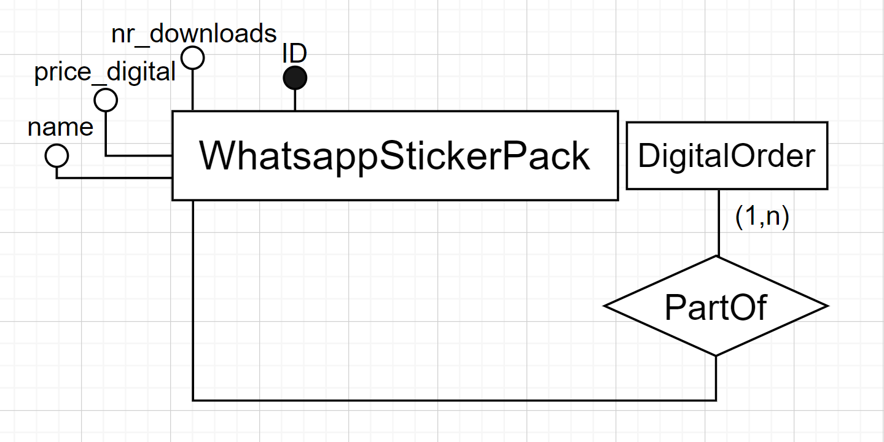

Redundancy: nr_downloads

**From Table Of Volumes**

|  |  |  |
| --- | --- | --- |
| **Concept** | **Construct** | **Volume** |
| WhatsappStickerPack | Entity | 6 000 |
| DigitalOrder | Entity | 10 000 |
| PartOf | Relationship | 18 000 |

**Operations**

|  |  |  |
| --- | --- | --- |
| **Operation** | **Type** | **Frequency** |
| 1. A new digital order is made, composed of Whatsapp sticker packs | Interactive | 500 / day |
| 2. Shows the user all the information of the Whatsapp sticker pack, including its nr of downloads | Interactive | 1k / day |

**Access Tables & Cost WITHOUT REDUNDANCY**

|  |  |  |  |  |
| --- | --- | --- | --- | --- |
| **Operation** | **Concept** | **Construct** | **Accesses** | **Type** |
| 1 | DigitalOrder | Entity | 1 | W |
| 1 | PartOf | Relationship | 1.8 (18 000 / 10 000) | W |
| 2 | WhatsappStickerPack | Entity | 1 | R |
| 2 | PartOf | Relationship | 3 (18 000 / 6 000) | R |

Costs:  
- OP1: 1 400 write a day  
- OP2: 4 000 read a day

Assuming that a W cost is like two R,  
TOTAL: 6 800 accesses per day

**Access Tables & Cost WITH REDUNDANCY**

|  |  |  |  |  |
| --- | --- | --- | --- | --- |
| **Operation** | **Concept** | **Construct** | **Accesses** | **Type** |
| 1 | DigitalOrder | Entity | 1 | W |
| 1 | WhatsappStickerPack | Entity | 1.8 (like PartOf because circa 1.8 sticker packs for each order) | W |
| 1 | PartOf | Relationship | 1.8 (18 000 / 10 000) | W |
| 2 | WhatsappStickerPack | Entity | 1 | R |

Costs:  
- OP1: 2 300 write a day  
- OP2: 1 000 read a day

Assuming that a W cost is like two R,  
TOTAL: 5 600 accesses per day

* **Redundancy of “nr_downloads” is kept**

**Concepts Interested**

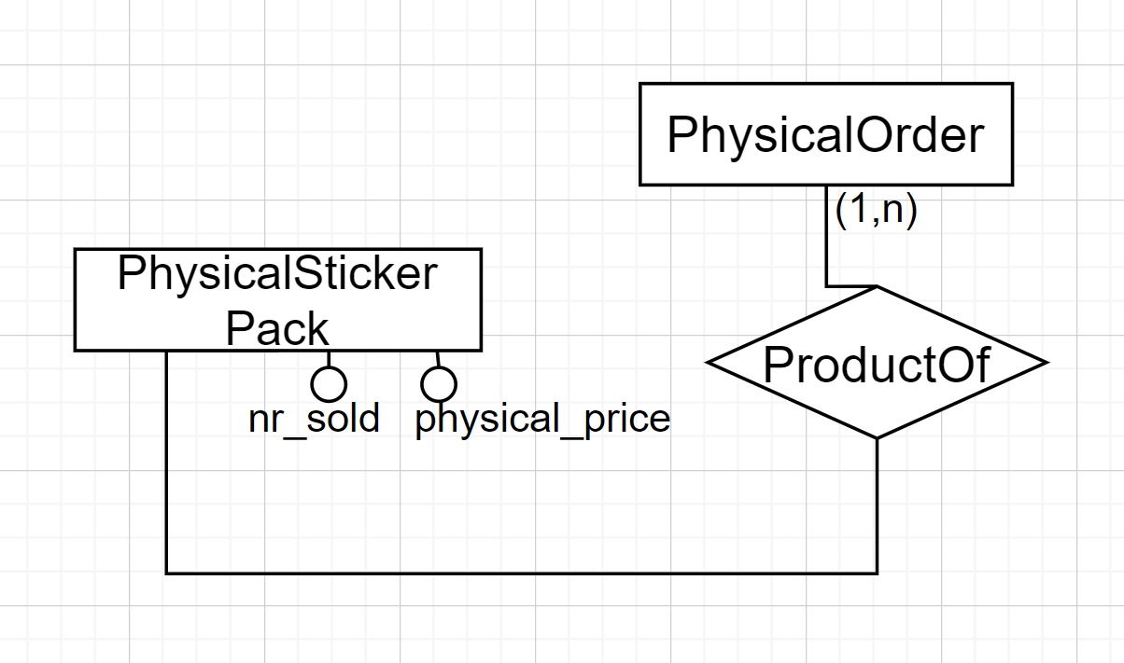

Redundancy: nr_sold

**From Table Of Volumes**

|  |  |  |
| --- | --- | --- |
| **Concept** | **Construct** | **Volume** |
| PhysicalStickerPack | Entity | 4 000 |
| PhysicalOrder | Entity | 4 000 |
| ProductOf | Relationship | 6 000 |

**Operations**

|  |  |  |
| --- | --- | --- |
| **Operation** | **Type** | **Frequency** |
| 1. A new Physical Order is made, composed of Physical Sticker Packs | Interactive | 10 / day |
| 2. Shows the user all the information of the Physical sticker pack, including its nr of pack sold | Interactive | 500 / day |

**Access Tables & Cost WITHOUT REDUNDANCY**

|  |  |  |  |  |
| --- | --- | --- | --- | --- |
| **Operation** | **Concept** | **Construct** | **Accesses** | **Type** |
| 1 | PhysicalOrder | Entity | 1 | W |
| 1 | ProductOf | Relationship | 1.5 (6 000 / 4 000) | W |
| 2 | PhysicalStickerPack | Entity | 1 | R |
| 2 | ProductOf | Relationship | 1,5 (6 000 / 4 000) | R |

Costs:  
- OP1: 25 write a day  
- OP2: 1 250 read a day

Assuming that a W cost is like two R,  
TOTAL: 1 300 accesses per day

**Access Tables & Cost WITH REDUNDANCY**

|  |  |  |  |  |
| --- | --- | --- | --- | --- |
| **Operation** | **Concept** | **Construct** | **Accesses** | **Type** |
| 1 | PhysicalOrder | Entity | 1 | W |
| 1 | PhysicalStickerPack | Entity | 1.5 (like ProductOf because circa 1.5 sticker packs for each order) | W |
| 1 | ProductOf | Relationship | 1.5 (6 000 / 4 000) | W |
| 2 | PhysicalStickerPack | Entity | 1 | R |

Costs:  
- OP1: 40 write a day  
- OP2: 500 read a day

Assuming that a W cost is like two R,  
TOTAL: 580 accesses per day

* **Redundancy of “nr_sold” is kept**

**DIRECT TRANSLATION TO THE RELATIONAL MODEL**

**Relational Schema**

User(email, nickname, password)  
key: nickname

Designer(email, email_payment, level, VAT*)  
fk: Designer[email] ⊆ User[email]  
fk: Designer[email] ⊆ InvoiceTo[Designer]

Client(email)  
fk: Client[email] ⊆ User[email]  
fk: Client[email] ⊆ Live[Client]

InvoiceTo (Designer, province, nation, CAP, street)  
fk: InvoiceTo[Designer] ⊆ Designer[email]  
fk: InvoiceTo[province, nation, CAP, street] ⊆ Address[province, nation, CAP, street]

Live(Client, province, nation, CAP, street)  
fk: Live[Client] ⊆ Client[email]  
fk: Live[province, nation, CAP, street] ⊆ Address[province, nation, CAP, street]

Address(province, nation, CAP, street, city)

Design(WhatsappStickerPack, Designer, dt_upload)  
fk: Design[WhatsappStickerPack] ⊆ WhatsappStickerPack[ID]  
fk: Design[Designer] ⊆ Designer[email]

Make(Order, Client)  
fk: Make[Order] ⊆ Order[ID]  
fk: Make[Client] ⊆ Client[email]

WhatsappStickerPack (ID, nr_downloads, price_digital, name)  
fk: WhatsappStickerPack[ID] ⊆ Design[WhatsappStickerPack]  
inclusion: WhatsappStickerPack[ID] ⊆ Image[ID]

Image(ID, order, image_file)  
fk: Image[ID] ⊆ WhatsappStickerPack[ID]  
key: {ID, image_file}

PhysicalStickerPack(ID, nr_sold, physical_price)  
fk: PhysicalStickerPack [ID] ⊆ WhatsappStickerPack[ID]

NFTPack(ID, link)  
fk: NFTPack[ID] ⊆ WhatsappStickerPack[ID]

Order(ID, date)  
fk: Order[ID] ⊆ Make[Order]

DigitalOrder(ID)  
fk: DigitalOrder[ID] ⊆ Order[id]  
inclusion: DigitalOrder[ID] ⊆ PartOf[DigitalOrder]

PhysicalOrder(ID)  
fk: PhysicalOrder[ID] ⊆ Order[ID]  
fk: PhysicalOrder[ID] ⊆ ProductOf[PhysicalOrder]

PartOf(DigitalOrder, WhatsappStickerPack)  
fk: PartOf[DigitalOrder] ⊆ DigitalOrder[ID]  
fk: PartOf[WhatsappStickerPack] ⊆ WhatsappStickerPack[ID]

ProductOf(PhysicalOrder, PhysicalStickerPack)  
fk: ProductOf[PhysicalOrder] ⊆ PhysicalOrder[ID]  
fk: ProductOf[PhysicalStickerPack] ⊆ PhysicalStickerPack[ID]

ShippedBy(PhysicalOrder, province, nation, CAP, street, ShippingCompany)  
fk: ShippedBy[PhysicalOrder] ⊆ PhysicalOrder[ID]  
fk: ShippedBy[province, nation, CAP, street] ⊆ Address[province, nation, CAP, street]  
fk: ShippedBy[ShippingCompany] ⊆ ShippingCompany[acronym]

ShippingCompany(acronym, name, fee)  
inclusion: ShippingCompany[acronym] ⊆ WorkIn[ShippingCompany]

WorkIn(ShippingCompany, Nations)  
fk: WorkIn[ShippingCompany] ⊆ ShippingCompany[acronym]  
fk: WorkIn[Nations] ⊆ Nations[acronym]

Nations(acronym)  
inclusion: Nations[acronym] ⊆ WorkIn[Nations]

PrintedBy(PhysicalOrder, PrintingEntity)  
fk: PrintedBy[PhysicalOrder] ⊆ PhysicalOrder[ID]  
fk: PrintedBy[PrintingEntity] ⊆ PrintingEntity[VAT]

PrintingEntity(VAT, name)  
fk: PrintingEntity[VAT] ⊆ LocatedIn[PrintingEntity]

PrintingCompany(VAT, pec_email)  
fk: PrintingCompany[VAT] ⊆ PrintingEntity[VAT]

LocalPrintingShop (VAT, phone_number)  
fk: LocalPrintingShop[VAT] ⊆ PrintingEntity[VAT]

LocatedIn(PrintingEntity, province, nation, CAP, street)  
fk: LocatedIn[PrintingEntity] ⊆ PrintingEntity[VAT]  
fk: LocatedIn[province, nation, CAP, street] ⊆ Address[province, nation, CAP, street]

**External Constraints**

* DigitalOrder[ID] ∩ PhysicalOrder[ID] = Ø  
  Order[ID] ⊆ DigitalOrder[ID] ∪ PhysicalOrder[ID]
* PrintingCompany[VAT] ∩ LocalPrintingShop[VAT] = Ø   
  PrintingEntity[VAT] ⊆ PrintingCompany [VAT] ∪ LocalPrintingShop[VAT]
* ∀ (x,y) ∈ PrintedBy, if y ∈ PrintingCompany[VAT] then x ∈ ShippedBy[PhysicalOrder]
* Attribute “level” has a range [1,6]
* ∀ (i,n) ∈ WhatsappStickerPack[ID,nr_downloads], n is equal to the number of tuples (d,w) ∈ PartOf such that w = i.
* ∀ (i,n) ∈ PhysicalStickerPack[ID,nr_sold], n is equal to the number of tuples (d,w) ∈ ProductOf such that w = i.
* User[email] ⊆ Client[email] ∪ Designer[email]
* ∀ x ∈ WhatsappStickerPack[ID], there can be at most 100 tuples (id,o,if) ∈ Image such that id=x.

**APPLICATION LOAD**

**Table of Volumes**

|  |  |
| --- | --- |
| **Relation** | **Volume** |
| User | 10 000 |
| Designer | 2 000 |
| Client | 9 000 |
| Address | 12 800 |
| WhatsappStickerPack | 6 000 |
| Image | 90 000 |
| PhysicalStickerPack | 4 000 |
| NFTPack | 4 000 |
| Order | 14 000 |
| DigitalOrder | 10 000 |
| PhysicalOrder | 4 000 |
| ShippingCompany | 100 |
| Nations | ~ 200 |
| PrintingEntity | 800 |
| PrintingCompany | 200 |
| LocalPrintingShop | 600 |
| Design | 6 000 |
| InvoiceTo | 2 000 |
| Live | 9 000 |
| Make | 14 000 |
| PartOf | 18 000 |
| ProductOf | 6 000 |
| ShippedBy | 2 500 |
| WorkIn | >= 100 |
| PrintedBy | 4 000 |
| LocatedIn | 800 |

**Table of Operations**

|  |  |  |
| --- | --- | --- |
| **Operation** | **Type** | **Frequency** |
| 1. Client displays their past orders | Interactive | 500 / day |
| 2. Client/Designer searches most downloaded WhatsappStickerPacks | Interactive | 10k / day |
| 3. Client/Designer wants to display all images of a WhatsappStickerPack | Interactive | 1k / day |
| 4. Client makes a new DigitalOrder | Interactive | 500 / day |
| 5. Client changes his/her address | Interactive | 10 / day |

**Frequent Accesses**

a. When we access an order, we often want to know who made this order  
b. When we access a WhatsappStickerPack, we often want to know if it is available also as Physical and/or NFTpack  
c. When we access a WhatsappStickerPack we often want to know its designer and the date when it has been created (uploaded)  
d. When we access a PrintingEntity we often want to know where it is located

**RESTRUCTURING OF THE RELATIONAL SCHEMA**

**From Application Load**

a. When we access an order, we often want to know who made this order  
b. When we access a WhatsappStickerPack, we often want to know if it is available also as Physical and/or NFTpack  
c. When we access a WhatsappStickerPack we often want to know its designer and the date when it has been created (uploaded)  
d. When we access a PrintingEntity we often want to know where it is located

**Taking into account those statements, the followings have been performed:**

1. Due to (a) we merge Make into Order  
2. Due to (b) we merge NFTPack into WhatsappStickerPack as the attribute ‘link’ which can be null and is null if no NFTPack corresponds or contains the link of NFTPack if there’s one. Moreover, we merge also PhysicalStickerPack into WhatsappStickerPack as the attributes ‘nr_sold’ and ‘physical_price’ that are both null if no PhysicalStickerPack corresponds or they are both non null if instead there’s a PhysicalStickerPack associated.  
3. Due to (c) we merge Design into WhatsappStickerPack  
4. Due to (d) we merge LocatedIn into PrintingEntity  
5. We remove Client because it is a useless relation, but we rename Live again as Client because it is more meaningful, renaming also its primary key as ‘email’.  
6. We remove Nations since it is a useless relation.  
7. We remove DigitalOrder because it is a useless relation.  
8. We remove PhysicalOrder because it is a useless relation.

**Restructured Relational Schema**

User(email, nickname, password)  
key: nickname

Designer(email, email_payment, level, VAT*)  
fk: Designer[email] ⊆ User[email]  
fk: Designer[email] ⊆ InvoiceTo[Designer]

InvoiceTo (Designer, province, nation, CAP, street)  
fk: InvoiceTo[Designer] ⊆ Designer[email]  
fk: InvoiceTo[province, nation, CAP, street] ⊆ Address[province, nation, CAP, street]

Client(email, province, nation, CAP, street)  
fk: Client[email] ⊆ User[email]  
fk: Client[province, nation, CAP, street] ⊆ Address[province, nation, CAP, street]

Address(province, nation, CAP, street, city)

WhatsappStickerPack (ID, nr_downloads, price_digital, name, Designer, dt_upload, nr_sold*, physical_price*, link*)  
fk: WhatsappStickerPack[Designer] ⊆ Designer[email]  
inclusion: WhatsappStickerPack[ID] ⊆ Image[ID]

Image(ID, order, image_file)  
fk: Image[ID] ⊆ WhatsappStickerPack[ID]  
key: {ID, image_file}

Order(ID, date, Client)   
fk: Order[Client] ⊆ Client[email]

PartOf(DigitalOrder, WhatsappStickerPack)  
fk: PartOf[DigitalOrder] ⊆ Order[ID]  
fk: PartOf[WhatsappStickerPack] ⊆ WhatsappStickerPack[ID]

ProductOf(PhysicalOrder, PhysicalStickerPack)  
fk: ProductOf[PhysicalOrder] ⊆ PrintedBy[PhysicalOrder]  
fk: ProductOf[PhysicalStickerPack] ⊆ WhatsappStickerPack[ID]

ShippedBy(PhysicalOrder, province, nation, CAP, street, ShippingCompany)  
fk: ShippedBy[PhysicalOrder] ⊆ PrintedBy[PhysicalOrder]  
fk: ShippedBy[province, nation, CAP, street] ⊆ Address[province, nation, CAP, street]  
fk: ShippedBy[ShippingCompany] ⊆ ShippingCompany[acronym]

ShippingCompany(acronym, name, fee)  
inclusion: ShippingCompany[acronym] ⊆ WorkIn[ShippingCompany]

WorkIn (ShippingCompany, Nations)  
fk: WorkIn[ShippingCompany] ⊆ ShippingCompany[acronym]

PrintedBy(PhysicalOrder, PrintingEntity)  
fk: PrintedBy[PhysicalOrder] ⊆ Order[ID]  
fk: PrintedBy[PrintingEntity] ⊆ PrintingEntity[VAT]

PrintingEntity(VAT, name, province, nation, CAP, street)   
fk: PrintingEntity[province, nation, CAP, street] ⊆ Address[province, nation, CAP, street]

PrintingCompany(VAT, pec_email)  
fk: PrintingCompany[VAT] ⊆ PrintingEntity[VAT]

LocalPrintingShop (VAT, phone_number)  
fk: LocalPrintingShop[VAT] ⊆ PrintingEntity[VAT]

**External Constraints**

* PartOf[DigitalOrder] ∩ PrintedBy[PhysicalOrder] = Ø   
  Order[ID] ⊆ PartOf[DigitalOrder] ∪ ProductOf[PhysicalOrder].
* PrintingCompany[VAT] ∩ LocalPrintingShop[VAT] = Ø   
  PrintingEntity[VAT] ⊆ PrintingCompany [VAT] ∪ LocalPrintingShop[VAT].
* ∀ (x,y) ∈ PrintedBy, if y ∈ PrintingCompany[VAT] then x ∈ ShippedBy[PhysicalOrder].
* Attribute “level” has a range [1,6].
* ∀ (i,n) ∈ WhatsappStickerPack[ID,nr_downloads], n is equal to the number of tuples (d,w) ∈ PartOf such that w = i.
* ∀ (i,n) ∈ WhatsappStickerPack[ID,nr_sold], n is equal to the number of tuples (d,w) ∈ ProductOf such that w = i.
* User[email] ⊆ Client[email] ∪ Designer[email].
* ∀ (a,b) ∈ WhatsappStickerPack[nr_sold, physical_price], a is NULL iff b is NULL.
* ∀ x ∈ WhatsappStickerPack[ID], there can be at most 100 tuples (id,o,if) ∈ Image such that id=x.

**APPLICATION LOAD**

**Table of Volumes**

|  |  |
| --- | --- |
| **Relation** | **Volume** |
| User | 10 000 |
| Designer | 2 000 |
| Client | 9 000 |
| Address | 12 800 |
| WhatsappStickerPack | 6 000 |
| Image | 90 000 |
| Order | 14 000 |
| ShippingCompany | 100 |
| PrintingEntity | 800 |
| PrintingCompany | 200 |
| LocalPrintingShop | 600 |
| InvoiceTo | 2 000 |
| PartOf | 18 000 |
| ProductOf | 6 000 |
| ShippedBy | 2 500 |
| WorkIn | >= 100 |
| PrintedBy | 4 000 |

**Table of Operations**

|  |  |  |
| --- | --- | --- |
| **Operation** | **Type** | **Frequency** |
| 1. Client displays their past orders | Interactive | 500 / day |
| 2. Client/Designer searches most downloaded WhatsappStickerPacks | Interactive | 10k / day |
| 3. Client/Designer wants to display all images of a WhatsappStickerPack | Interactive | 1k / day |
| 4. Client makes a new Order of WhatsappStickerPacks | Interactive | 500 / day |
| 5. Client changes his/her address | Interactive | 10 / day |